a!richTextDisplayField(

labelPosition: "COLLAPSED",

value: {

a!richTextItem(

text: "Agenda",

style: "HEADER_MEDIUM"

),

a!richTextItem(

text: "Top 3",

style: "HEADER_SMALL"

),

a!richTextNumberedList(

items: {

a!richTextItem(

text: {

"Update ",

a!richTextItem(

text: "website",

link: a!safeLink(

uri: "http://www.appian.com",

label: "Company website"

)

)

}

),

a!richTextItem(

text: {

"Yearly budget - due ",

a!richTextItem(

text: "Jan 1, 2015",

style: "STRONG"

)

}

),

"Growth strategy"

}

),

a!richTextItem(

text: "Lower Priority",

style: "HEADER_SMALL"

),

a!richTextBulletedList(

items: {

a!richTextListItem(

text: "Department updates",

nestedList: a!richTextBulletedList(

items: {

"Sales",

"Engineering",

"Finance",

"Professional Services"

}

)

),

a!richTextItem(

text: {

"Market analysis for ",

a!richTextItem(

text: "North America",

style: "EMPHASIS"

),

" and ",

a!richTextItem(

text: "Europe",

style: "EMPHASIS"

)

}

)

}

)

}

)

Displays the following:

<https://forum.appian.com/suite/help/7.7/images/RichTextExample.png>

# Embedding SAIL in HTML5

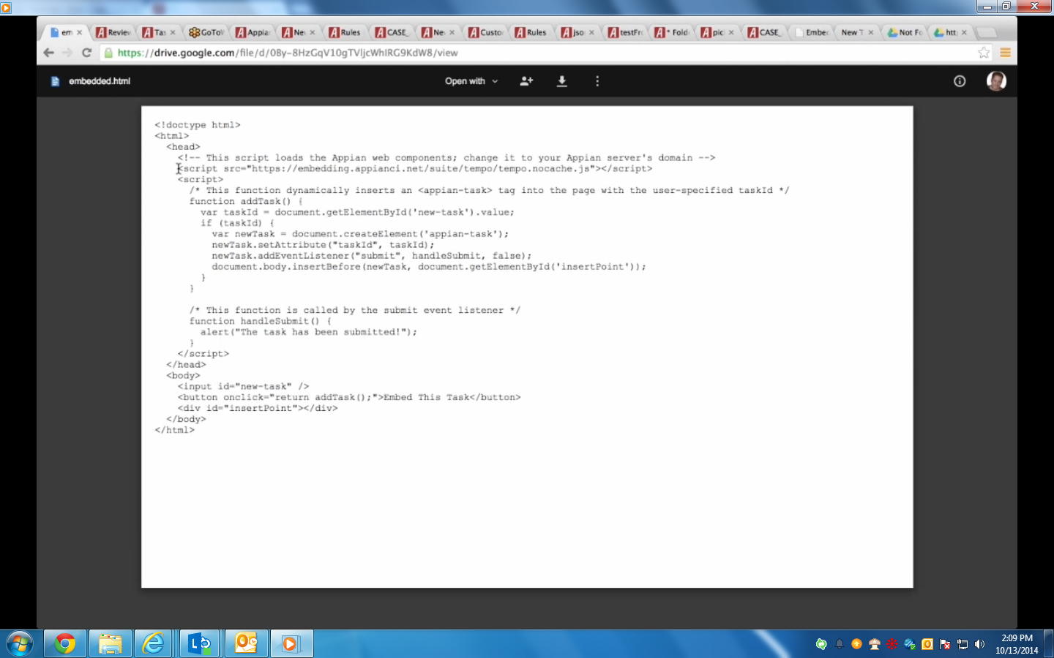

# Multiple Pickers e.g. people, Document and Custom picker.

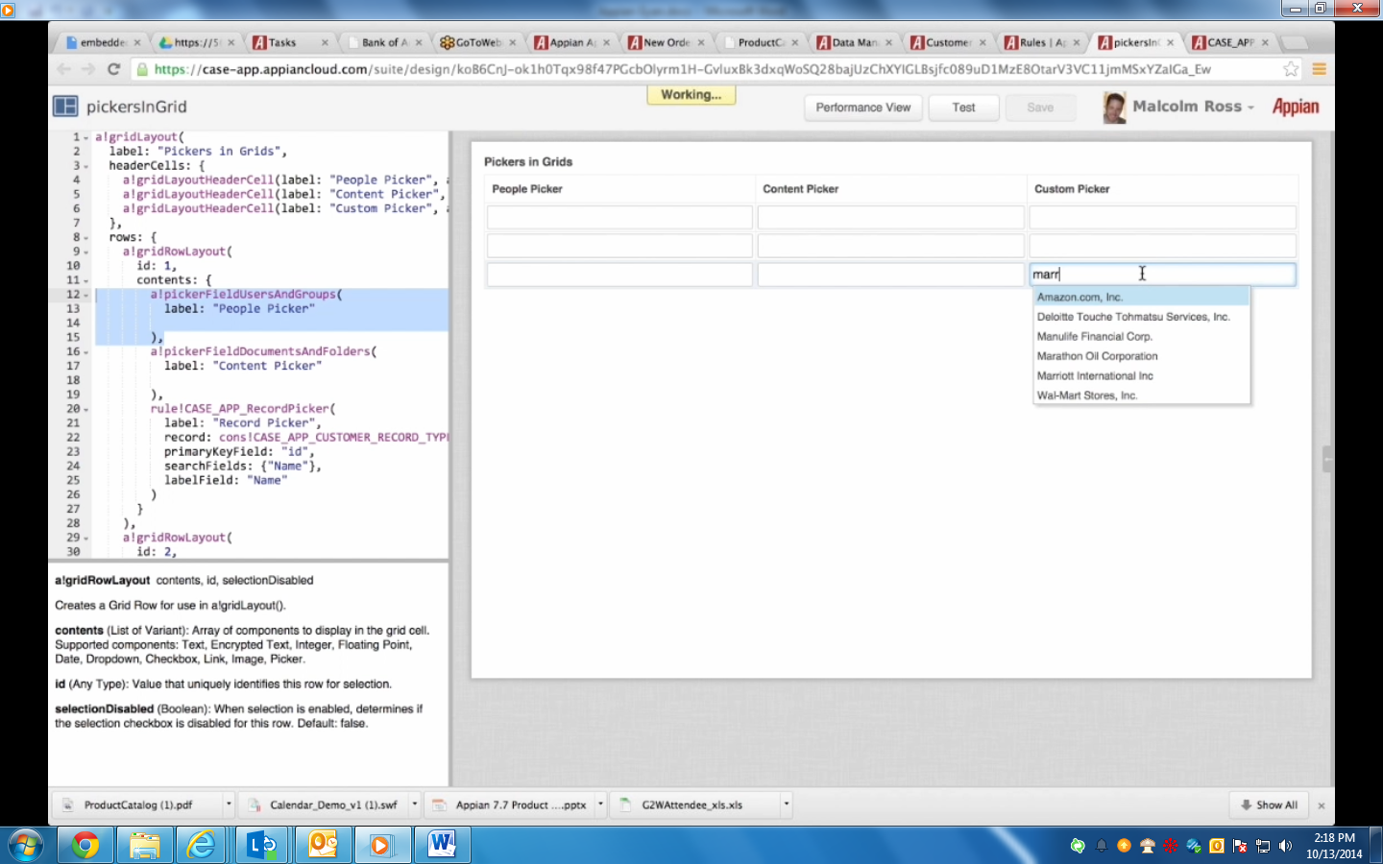

# Folder browser

